## **Access to Student Apps from Home**

1. To use on a computer, go to **https://clever.com.**This works best in ***Chrome, Edge, or FireFox****. Internet Explorer will not support the graphics in the games.*
2. Click **“Log in as a student”** in the top right corner.

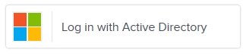

1. Search for **your school name.** Then click on
2. Students will then need to log-in using CCPS log-in information.Their email will be **(Their Username**)@star.carrollk12.org. Click “Next” and enter their **CCPS password**.
3. Once in Clever, students click on the **App (Connect Ed (McGraw Hill), Lexia, Dreambox, Discovery Ed)**.

